Requirements

1 – The POS system shall integrate with an external payment processor. 1

2 - The POS system shall provide a data dump for sales and purchases via ETL process to the accounting software. 2

3 - The system must be able to add new inventory items (products) with no duplicate records. 7

4 - The system must be able to add new vendors. 9

5- The system must be able to update the vendor information. 11

6 - The system must be able to display the beverage inventory belonging to a given vendor. 13

7 - The system must produce a formatted report of all products and available quantities for every vendor. 15

8 – The system must display original prices and current prices, % difference in price from current to original, daily high price for products, daily low price for products. 18

9 – The system must display prices for most recently sold products. 20

10 – The system must display top selling products of the day. 21

11 -The system must create a nightly backup, after normal business hours, and differential backups throughout the day. 22

12 – The system must be able to update product prices based on sales. 25

13 – The system must be update real-time inventory levels according to sales 27

14 - The system must update real-time inventory levels according to sales. 31

15 – The system must be able to display the unpaid items for a customer. 33

16 - The system must be able to predict when to order inventory based on sales and current inventory levels. 35

17 - The system must be able to generate profit report. 37

18- The system must be able to display total number of inventory sold by type per day 39

19 – The system must be able to display total revenue for a day 42

20 - The system must display monthly sales reports. 44

21- The system must display monthly purchase reports. 46

22 – The system shall keep historical data. 48

23 - The system must insert new purchases and update the inventory levels in the product table. 50

24 – The system must reset prices to their base levels. 52

25 - The system must be able to add new product types without duplicates. 53

26 - The system must be able to insert new customers without duplicates. 55

# 1 – The POS system shall integrate with an external payment processor.

GB accepts cash, debit cards and credit card as a payment method. To process the card payments, GB has decided to use MegaPath’s services. MegaPath Corporation is a business telecommunication company that provides voice, private network, data security, cloud services to the retail industry. This external payment processor is complied with Payment Card Industry (PCI) requirement for data security which allows GB a private network connection to a wide variety of payment processors such as debit & credit cards. Following are the steps that are followed during the payment process:

* Megapath’s Payment Processor Extranet connects with GB’s MPLS VPN
* It securely transfers the card payment (debit & credit card information) from GB store location to payment processors
* All the back-end functions of routing the card information to banks for validating customer’s available fund are done at MegaPath’s end
* Depending on the message provided from Bank to MegaPath Payment processor, the transaction is either approved or declined

# 2 - The POS system shall provide a data dump for sales and purchases via ETL process to the accounting software.

--SSIS Integration Service

--Create a table to transfer the data

IF OBJECT_ID('dbo.t_combo', 'U') IS NOT NULL

drop table dbo.t_combo

create table dbo.t_combo

(pro_id int,

cus_id int,

ty_id int ,

ty_description varchar(50),

pro_price decimal(5,2));

--Following data needs to be transferred

Select ts.pro_id,ts.cus_id,tp.ty_id,tt.ty_description,ts.pro_price from

T_pos_sales ts join T_product tp on ts.pro_id=tp.pro_id join t_type tt on tp.ty_id=tt.ty_id



1. Select new project



1. Integration service



1. Give it a name and save



1. Drag data flow in control flow window:
2. Connecting sources database with source assistant:



1. Adding source connection:

-Then



1. Connect with destination database by using SQL server destination assistant



1. After edit: select the name of database



1. Mapping the table: source table to destination table



1. To run this integration



- After execution



-Data is transferred to combo:



# 3 - The system must be able to add new inventory items (products) with no duplicate records.

The following code creates a stored procedure to add new items. It validates that the product does already exist in the system and that the product does have a valid type.

use gibino

if objectproperty(object_id('dbo.sp_add_product'), N'IsProcedure') = 1

drop procedure dbo.sp_add_product

go

create procedure sp_add_product

(@pro_name varchar(30), @pro_instock int, @ty_id int, @pro_base numeric(5,2))

as

begin

--Checks for duplicate product names. Both differing cases and spacing are accommodated.

if exists (select * from t_product where upper(replace(pro_name, ' ', ''))=upper(replace(@pro_name, ' ', '')))

begin

select @pro_name, 'already exists in this system as a product.'

return

end

else

--Checks that type is valid

if not exists (select * from t_type where ty_id=@ty_id)

begin

select @pro_name, 'was not given a valid type.'

return

end

--Inserts product data into t_product table

begin transaction

insert into t_product

(pro_name, pro_instock, ty_id, pro_base)

values

(@pro_name, @pro_instock, @ty_id, @pro_base)

--Message for rollback

if @@error<>0

begin

rollback transaction

select 'Product ', @pro_name, ' not added'

return

end

--Message for success

commit transaction

select 'Product ', @pro_name, ' was added'

end

This screen shot demonstrates the successful insertion of a product.

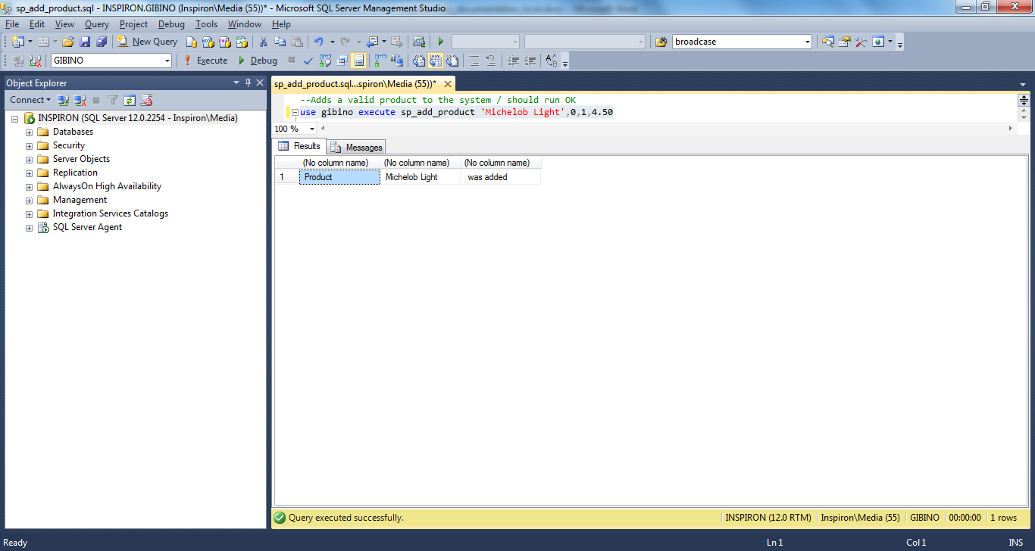

This screen shot demonstrates a failed attempt to insert an existing product. The product was matched, even though the case and spacing had changed.

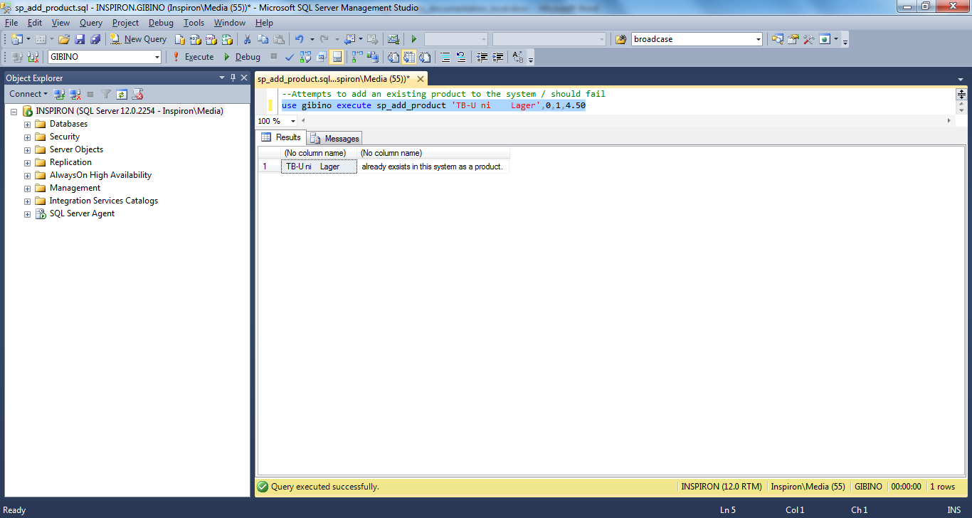

This screen shot demonstrates a failed attempt to insert a product with an invalid type.

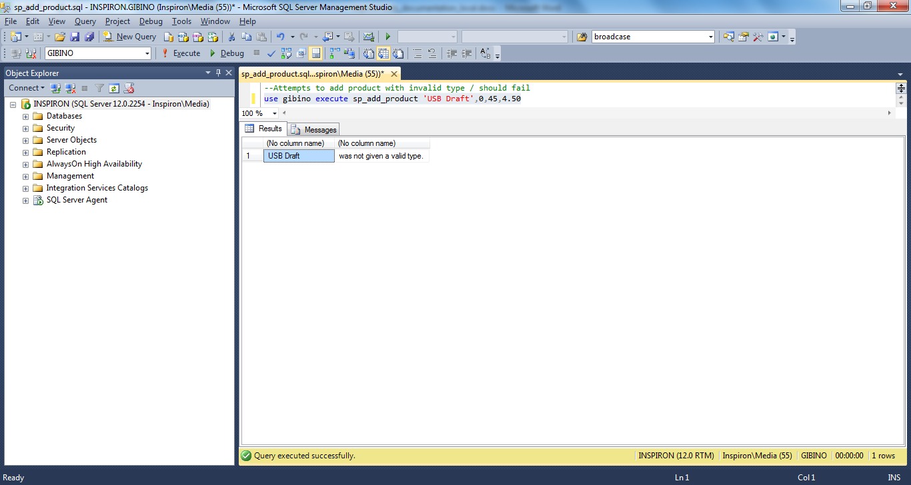

# 4 - The system must be able to add new vendors.

The following code creates a stored procedure to add new vendors. It validates that the vendor’s name does not already exist in the system.

use gibino

if objectproperty(object_id('dbo.sp_add_vendor'), N'IsProcedure') = 1

drop procedure dbo.sp_add_vendor

go

create procedure sp_add_vendor

(@ven_name varchar(30),@ven_street1 varchar(30), @ven_street2 varchar(30), @ven_city varchar(30) , @ven_state char(2),

@ven_zip numeric(5,0), @ven_phone varchar(12), @ven_email varchar(50),@ven_contact varchar(50))

as

begin

--Checks for duplicate vendor names. Both differing cases and spacing are accommodated.

if exists (select * from t_vendor where upper(replace(ven_name, ' ',''))=upper(replace(@ven_name, ' ','')))

begin

select @ven_name, 'already exsists in this system as a vendor'

return

end

--Inserts vendor information into t_vendor table

begin transaction

insert into t_vendor

(ven_name,ven_street1, ven_street2, ven_city, ven_state,

ven_zip, ven_phone, ven_email, ven_contact)

values

(@ven_name,@ven_street1, @ven_street2, @ven_city, @ven_state,

@ven_zip, @ven_phone, @ven_email, @ven_contact)

--Message for rollback

if @@error<>0

begin

rollback transaction

select 'Vendor ', @ven_name, ' not added'

return

end

--Message for success

commit transaction

select 'Vendor ', @ven_name, ' was added'

end

This screen shot demonstrates the successful insertion of a new vendor.



This screen shot demonstrates a failed attempt to insert a new vendor with an existing name.



# 5- The system must be able to update the vendor information.

The following code demonstrates the creation of a stored procedure, which allows the user to update the information for a given vendor. It validates that the vendor name is not updated to the name of an existing vendor.

use gibino

if objectproperty(object_id('dbo.sp_update_vendor'), N'IsProcedure') = 1

drop procedure dbo.sp_update_vendor

go

create procedure sp_update_vendor

(@ven_id int, @ven_name varchar(30),@ven_street1 varchar(30), @ven_street2 varchar(30), @ven_city varchar(30) , @ven_state char(2),

@ven_zip numeric(5,0), @ven_phone varchar(12), @ven_email varchar(50),@ven_contact varchar(50))

as

begin

--Checks for that another vendor, with the same name, does not exist. Accommodates for differing capitalization and spacing.

if exists (select * from t_vendor where upper(replace(ven_name, ' ', '' ))=upper(replace(@ven_name, ' ', '' )) and ven_id <> @ven_id)

begin

select @ven_name, 'already exsists in this system as a vendor. Please check that you have the correct vendor information.'

return

end

else

--Checks that the vendor exists in the system

if not exists (select * from t_vendor where ven_id = @ven_id)

begin

select @ven_id, ' is not found, as a vendor, in the system.'

return

end

--Updates vendor information in t_vendor table

begin transaction

update t_vendor set

ven_name=@ven_name, ven_street1=@ven_street1, ven_street2=@ven_street2, ven_city=@ven_city, ven_state=@ven_state,

ven_zip=@ven_zip, ven_phone=@ven_phone, ven_email=@ven_email, ven_contact=@ven_contact

where ven_id=@ven_id

--Message for rollback

if @@error<>0

begin

rollback transaction

select 'Vendor ', @ven_name, ' was not updated'

return

end

--Message for success

commit transaction

select 'Vendor ', @ven_name, ' was updated'

end

This shows the successful name change for a vendor.

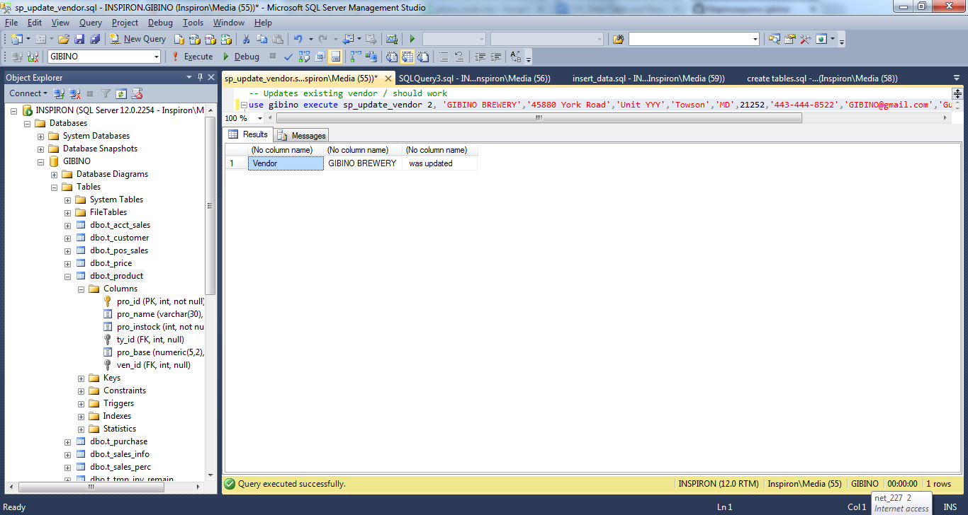

This shows the resulting error that occurs when the user attempts to update the vendor’s name to the name of another vendor.



# 6 - The system must be able to display the beverage inventory belonging to a given vendor.

The following code creates a stored procedure which can be used to query the inventory for a given vendor. It validates that the vendor exists in the system.

use gibino

if objectproperty(object_id('dbo.sp_inventory_by_vendor'), N'IsProcedure') = 1

drop procedure dbo.sp_inventory_by_vendor

go

create procedure sp_inventory_by_vendor

(@ven_id int)

as begin

--Checks that vendor exists

if exists (select * from t_vendor where ven_id=@ven_id)

begin

select v.ven_name as Vendor, p.pro_name as Product, p.pro_instock as Inventory

from t_vendor v left join t_product p on v.ven_id = p.ven_id

where v.ven_id=@ven_id

order by Vendor, Product

return

end

else

begin

select @ven_id, 'is not a valid vendor.'

return

end

--Message for rollback

if @@error<>0

begin

rollback transaction

select 'Transaction rolled back. There was an error.'

return

end

--Message for success

commit transaction

select 'Output success'

end

This screen shot demonstrates the stored procedure pulling the inventory for a given vendor.



This screenshot demonstrates the error that occurs when the stored procedure is run for a non-existent vendor.



# 7 - The system must produce a formatted report of all products and available quantities for every vendor.

This stored procedure uses nested cursors to produce a formatted report of products and inventories, by vendor.

use gibino

if objectproperty(object_id('dbo.sp_inventory_cursoring'), N'IsProcedure') = 1

drop procedure dbo.sp_inventory_cursoring

go

--This stored procedure uses two nested cursors to report on each vendor and the available products and inventory

--The first cursor (vendor_cursor) selects the vendors, one-by-one

--The second cursors (product_cursors) selects the products (beverages) and available inventory for each product

--for the current vendor in the vendor_cursor

create proc sp_inventory_cursoring

as begin

begin transaction

--Prevents the output from displaying row numbers.

set nocount on

--The various variables are declared. The length of the broadcase variable is set to 140, in case this cursor

--will be used for a twitter feed.

declare

@ven_id int, @ven_name varchar(30), @broadcast varchar(140), @pro_name varchar(30), @pro_instock int

--This is the title that will be presented at the top of the report

print 'INVENTORY REPORT, LISTS ALL VENDORS AND AVAILABLE QUANTITIES OF EACH BEVERAGE'

declare vendor_cursor cursor for

select ven_id, ven_name

from t_vendor

order by ven_name

open vendor_cursor

fetch next from vendor_cursor

into @ven_id, @ven_name

while @@fetch_status=0

begin

print ' '

select @broadcast = '---Beverages from Vendor ' + @ven_name

print @broadcast

-- The product_cursor, nested inside of the vendor_cursor begins here

declare product_cursor cursor for

select p.pro_name, p.pro_instock

from t_product p

where p.ven_id=@ven_id

order by p.pro_name

open product_cursor

fetch next from product_cursor into @pro_name, @pro_instock

if @@fetch_status <> 0

print ' This vendor does not have any products in the current inventory.'

while @@fetch_status=0

begin

--Had to cast the integer variable, pro_instock, into a varchar to concatenate it.

select @broadcast = ' ' + @pro_name + ', ' + cast(@pro_instock as varchar) + ' units in stock.'

print @broadcast

fetch next from product_cursor into @pro_name, @pro_instock

--Closes the product_cursor for the current vendor

end

close product_cursor

deallocate product_cursor

--Vendor_cursor moves to the next vendor the next vendor

fetch next from vendor_cursor

into @ven_id, @ven_name

end

--Vendor cursor closes

close vendor_cursor

deallocate vendor_cursor

--Message for rollback

if @@error<>0

begin

rollback transaction

select 'Transaction rolled back. There was an error.'

return

end

--Success will display report output

commit transaction

end

This screenshot shows the successful execution of the report.



# 8 – The system must display original prices and current prices, % difference in price from current to original, daily high price for products, daily low price for products.

The following code creates a stored procedure view the Price Report data with a date parameter.

/* CHECK IF PROCEDURE EXISTS, DROP AND RECREATE IT */

IF OBJECTPROPERTY(object_id('dbo.sp_price_report'), N'IsProcedure') = 1

DROP PROCEDURE [dbo].[sp_price_report]

GO

CREATE PROCEDURE dbo.sp_price_report

@date DATETIME

AS

BEGIN

BEGIN TRANSACTION

/* HELPER TABLE */

IF OBJECT_ID('dbo.t_price_diff', 'U') IS NOT NULL

DROP TABLE dbo.t_price_diff

CREATE TABLE dbo.t_price_diff

(

diff_id INT IDENTITY(1,1) PRIMARY KEY,

pro_id INT FOREIGN KEY REFERENCES dbo.t_product(pro_id),

diff_perc DECIMAL(5,1) NOT null

);

/* CALCULATE THE PRICE DIFFERENCES */

INSERT INTO T_PRICE_DIFF (PRO_ID, DIFF_PERC)

SELECT pri.pro_id, ((pri.pro_price - pro.pro_base)/pro.pro_base) * 100

FROM t_price pri INNER JOIN t_product pro

ON pri.pro_id = pro.pro_id;

/* ROLLBACK ON ERROR */

IF @@error <> 0

BEGIN

ROLLBACK TRANSACTION

SELECT ' There was a problem creating the price report'

RETURN

END

COMMIT TRANSACTION;

/* QUERY FOR THE REPORT */

SELECT pro.pro_name AS Product, pro.pro_base AS OriginalPrice, pri.pro_price AS CurrentPrice, d.diff_perc AS PercentageDifference

, (CASE WHEN max(s.pro_price) < pri.pro_price THEN pri.pro_price ELSE max(s.pro_price) END) AS DailyHigh

, min(s.pro_price) AS DailyLow

FROM t_price pri

INNER JOIN t_product pro ON pri.pro_id = pro.pro_id

INNER JOIN t_price_diff d ON d.pro_id = pri.pro_id

INNER JOIN t_pos_sales s ON s.pro_id = d.pro_id

WHERE DAY(s.pos_datetime) = DAY(@date)

GROUP BY pri.pro_id, pro.pro_name,pro.pro_base, pri.pro_price, d.diff_perc

UNION

/* ADD PRODUCTS WITH NO SALES */

SELECT pro.pro_name AS Product, pro.pro_base AS OriginalPrice, pri.pro_price AS CurrentPrice, 0 AS PercentageDifference, pro.pro_base AS DailyHigh, pro.pro_base AS DailyLow

FROM t_price pri

INNER JOIN t_product pro ON pri.pro_id = pro.pro_id

INNER JOIN t_price_diff d ON d.pro_id = pri.pro_id

WHERE pri.pro_id NOT IN (SELECT pro_id FROM t_pos_sales WHERE DAY(pos_datetime) = DAY(@date));

END

This screen capture demonstrates successful generation of a Price Report for the day input.



# 9 – The system must display prices for most recently sold products.

The following code will create a stored procedure to return the products sold within the last hour, the price they sold for and the time of sale.

/* CHECK IF PROCEDURE EXISTS, DROP AND RECREATE IT */

IF OBJECTPROPERTY(object_id('dbo.sp_recent_sales'), N'IsProcedure') = 1

DROP PROCEDURE [dbo].[sp_recent_sales]

GO

CREATE PROCEDURE dbo.sp_recent_sales

AS

BEGIN

SELECT pro_name AS Product, pro_price AS PriceSold, pos_datetime AS TimeOfSale

FROM t_pos_sales s

INNER JOIN t_product p ON p.pro_id = s.pro_id

WHERE pos_datetime > DateAdd(Hour, -1, GETDATE()) and pos_datetime < GETDATE();

END

This screen capture demonstrates the successful generation of a recent sales report.



# 10 – The system must display top selling products of the day.

The following code will create a stored procedure to generate a report of the top 3 products for the day.

/* CHECK IF PROCEDURE EXISTS, DROP AND RECREATE IT */

IF OBJECTPROPERTY(object_id('dbo.sp_top_sellers'), N'IsProcedure') = 1

DROP PROCEDURE [dbo].[sp_top_sellers]

GO

CREATE PROCEDURE dbo.sp_top_sellers

AS

BEGIN

/* SELECT TOP 3 SELLING PRODUCTS FOR THE CURRENT DAY */

SELECT top 3 pro_name, max(pos_qty) AS TopSeller

FROM t_pos_sales s

INNER JOIN t_product p ON p.pro_id = s.pro_id

WHERE Day(pos_datetime) = Day(GetDate())

GROUP BY p.pro_id, pro_name

ORDER BY TopSeller DESC;

END

This screen capture demonstrates successful generation of a top sellers report.



# 11 -The system must create a nightly backup, after normal business hours, and differential backups throughout the day.

The following code first demonstrates how to put the database into simple recovery mode. It then creates three stored procedures t setup (1) ad hoc, (2) full, and (3)differential backups.

--Sets database to simple recovery mode

alter database gibino set recovery simple;

-SP1-------------------------------------------------------------------------------------

--This does a "COPY ONLY" backup. It should be used when making a one-off (ad-hoc) backup

--It will not interfere with the relationship between the full and differential backups

use gibino

if objectproperty(object_id('dbo.sp_backup_adhoc'), N'IsProcedure') = 1

drop procedure dbo.sp_backup_adhoc

go

create proc sp_backup_adhoc

as

begin

backup database gibino to disk = 'C:\backups\GIBINO_ADHOC.bak' with copy_only;

--Message for problem

if @@error<>0

begin

select 'Problem creating ad hoc backup.'

return

end

end

--SP2-----------------------------------------------------------------------------------

--Does a full database backup / scheduled to run daily at 4AM / differential backups use this as their base

use gibino

if objectproperty(object_id('dbo.sp_backup_full'), N'IsProcedure') = 1

drop procedure dbo.sp_backup_full

go

create proc sp_backup_full

as

begin

backup database gibino to disk = 'C:\backups\GIBINO_FULL.bak';

--Message for problem

if @@error<>0

begin

select 'Problem creating full backup.'

return

end

end

--SP3-----------------------------------------------------------------------------------

--Does a differential backup (only backups changes since most recent full backup) / schedule to run every fifteen minutes

use gibino

if objectproperty(object_id('dbo.sp_backup_diff'), N'IsProcedure') = 1

drop procedure dbo.sp_backup_diff

go

create proc sp_backup_diff

as

begin

backup database gibino to disk = 'C:\backups\GIBINO_DIFFERENTIAL.bak' with differential;

--Message for problem

if @@error<>0

begin

select 'Problem creating differential backup.'

return

end

end

This screen capture shows that the full backup is a scheduled job, which runs at 4:00 AM every day.



This screen capture shows that the differential backup is a scheduled job, which runs every 15 minutes.



This screen capture demonstrates the output for a successful ad hoc backup.



These screen captures demonstrate the output and error messages for a failed (due to the backup location not existing) ad hoc backup.





# 12 – The system must be able to update product prices based on sales.

The following code will create a stored procedure to update product prices based on sales.

/* CHECK IF PROCEDURE EXISTS, DROP AND RECREATE IT */

IF OBJECTPROPERTY(object_id('dbo.sp_update_price_from_sales'), N'IsProcedure') = 1

DROP PROCEDURE [dbo].[sp_update_price_from_sales]

GO

CREATE PROCEDURE dbo.sp_update_price_from_sales

/* DATE PARAMETERS */

@start_time DATETIME,

@end_time DATETIME

AS

BEGIN

BEGIN TRANSACTION;

/* HELPER TABLE */

IF OBJECT_ID('dbo.t_sales_info', 'U') IS NOT NULL

DROP TABLE dbo.t_sales_info

CREATE TABLE dbo.t_sales_info

(

sal_id INT IDENTITY(1,1) PRIMARY KEY,

pro_id INT FOREIGN KEY REFERENCES dbo.t_product(pro_id),

qty_sold INT NOT null

);

/* GRAB ALL THE SALES FOR THE TIME PERIOD */

INSERT INTO T_SALES_INFO (PRO_ID, QTY_SOLD)

SELECT b.pro_id,sum(b.qty_sold)

FROM v_beer_sales b

WHERE time_of_sale between @start_time AND @end_time

GROUP BY b.pro_id

/* HELPER TABLE */

IF OBJECT_ID('dbo.t_sales_perc', 'U') IS NOT NULL

DROP TABLE dbo.t_sales_perc

CREATE TABLE dbo.t_sales_perc

(

sal_id INT IDENTITY(1,1) PRIMARY KEY,

pro_id INT FOREIGN KEY REFERENCES dbo.t_product(pro_id),

pct_of_sales INT NOT null

);

/* PERCENTAGE OF SALES MATH */

INSERT INTO T_SALES_PERC (PRO_ID, PCT_OF_SALES)

SELECT s.pro_id, ROUND(s.qty_sold * 100.0/(SELECT sum(s.qty_sold) FROM t_sales_info s),2)

FROM t_sales_info s

/* HELPER TABLE */

IF OBJECT_ID('dbo.t_price_adjust', 'U') IS NOT NULL

DROP TABLE dbo.t_price_adjust

CREATE TABLE dbo.t_price_adjust

(

pa_id INT IDENTITY(1,1) PRIMARY KEY,

pro_id INT FOREIGN KEY REFERENCES dbo.t_product(pro_id),

price_adjust DECIMAL(5,2) NOT null

);

/* PRICE ADJUSTMENT CALCULATIONS */

INSERT INTO T_PRICE_ADJUST(PRO_ID, PRICE_ADJUST)

SELECT p.pro_id, CASE

WHEN pct_of_sales = 0 THEN 0

WHEN pct_of_sales > 0 AND pct_of_sales < 20 THEN 0

WHEN pct_of_sales >= 20 AND pct_of_sales < 40 THEN .25

WHEN pct_of_sales >= 40 AND pct_of_sales < 60 THEN .5

WHEN pct_of_sales >= 60 AND pct_of_sales < 80 THEN .75

WHEN pct_of_sales >= 80 AND pct_of_sales <= 100 THEN 1

END

FROM t_sales_perc p;

/* UPDATE T_PRICE TABLE */

UPDATE p

SET p.pro_price = p.pro_price + pa.price_adjust

FROM T_PRICE p INNER JOIN T_PRICE_ADJUST pa

ON p.pro_id = pa.pro_id;

/* ROLLBACK IF THERE WAS AN ERROR */

IF @@error <> 0

BEGIN

ROLLBACK TRANSACTION

SELECT ' Price update was unsuccessful'

RETURN

END

COMMIT TRANSACTION;

SELECT * FROM T_PRICE;

END

This screen capture demonstrates successful update of product prices. Product 6 original price is $5.00 in this scenario and after the stored procedure is executed, the price is updated to $5.75 based on sales for 11/28 between 4 and 5 pm.

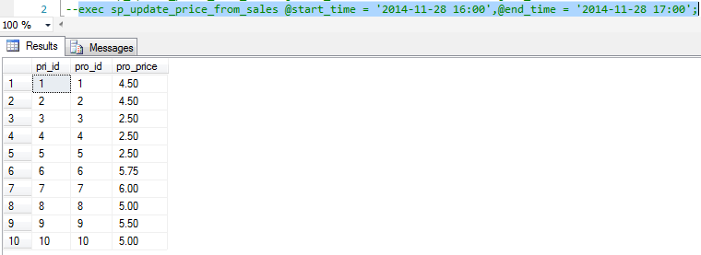

# 13 – The system must not be able to sell a quantity which exceeds the inventory available, and the system must not be able to sell inventory to a customer below the age of 21

The following code will create a stored procedure to create point of sale transactions. Once a sale is made and entry to the table is created and inventory levels are updated. There is validation for alcoholic products.

/* CHECK IF PROCEDURE EXISTS, DROP AND RECREATE IT */

IF OBJECTPROPERTY(object_id('dbo.sp_add_pos_sale'), N'IsProcedure') = 1

DROP PROCEDURE [dbo].[sp_add_pos_sale]

GO

CREATE PROCEDURE dbo.sp_add_pos_sale

@pro_id INT,

@pur_qty INT,

@cus_id INT,

@pos_paid INT

AS

BEGIN

/* VALIDATE PRODUCT */

IF NOT EXISTS(SELECT * FROM t_product WHERE pro_id = @pro_id)

BEGIN

SELECT 'This product does NOT exist!'

RETURN

END

/* VALIDATE CUSTOMER */

IF NOT EXISTS(SELECT * FROM t_customer WHERE cus_id = @cus_id)

BEGIN

SELECT 'This customer does NOT exist!'

RETURN

END

/* VALIDATE CUSTOMER */

IF @pur_qty <= 0

BEGIN

SELECT 'This is NOT a valid purchase amount!'

RETURN

END

/* VALIDATE SUFFICIENT INVENTORY */

IF NOT EXISTS(SELECT * FROM dbo.t_product WHERE pro_id=@pro_id AND pro_instock>=@pur_qty)

BEGIN

SELECT 'We do NOT have enough of this product IN stock. The amount IN stock is', (SELECT pro_instock FROM t_product WHERE pro_id=@pro_id)

RETURN

END

/* VALIDATE AGE FOR RESTRICTED ITEM */

IF EXISTS(SELECT * FROM t_product WHERE pro_id=@pro_id AND ty_id IN (SELECT ty_id FROM t_type WHERE ty_restricted=1))

BEGIN

/* CHECK FOR CUSTOMER AGE, CREATE A HELPER TABLE TO DETERMINE AGE */

BEGIN TRANSACTION

IF OBJECT_ID('dbo.t_cus_age', 'U') IS NOT NULL

DROP TABLE dbo.t_cus_age

CREATE TABLE dbo.t_cus_age

(

cage_id INT IDENTITY(1,1) PRIMARY KEY,

cus_id INT FOREIGN KEY REFERENCES dbo.t_product(pro_id),

age INT NOT null

);

INSERT INTO T_CUS_AGE(CUS_ID, AGE)

SELECT cus_id, DATEDIFF(hour, cus_dob, GETDATE())/8766 AS AgeInYears FROM t_customer;

/* CUSTOMER IS NOT OF AGE */

IF NOT EXISTS(SELECT * FROM t_cus_age a

INNER JOIN t_customer c ON a.cus_id = c.cus_id

WHERE age < 21 AND a.cus_id = @cus_id)

BEGIN

ROLLBACK TRANSACTION

SELECT 'Alcoholic beverages can only be purchased BY customers who are 21 years of age or older'

RETURN

END

COMMIT TRANSACTION

END

BEGIN TRANSACTION

/* CREATE A SALE */

insert into dbo.t_pos_sales(pos_qty, cus_id, pro_id, pos_paid, pro_price)

values(@pur_qty, @cus_id, @pro_id, @pos_paid, (SELECT pro_price FROM dbo.t_price WHERE pro_id = @pro_id));

update t_product

set pro_instock = (pro_instock - @pur_qty)

WHERE pro_id = @pro_id;

/* ROLLBACK IF AN ERROR HAS OCCURRED */

IF @@error <> 0

BEGIN

ROLLBACK TRANSACTION

SELECT ' Sale was NOT completed'

RETURN

END

COMMIT TRANSACTION;

SELECT * FROM t_pos_sales;

SELECT 'Sold ', @pur_qty, 'units of ', (SELECT pro_name FROM t_product WHERE pro_id = @pro_id), ' at ', (SELECT pro_price FROM t_price WHERE pro_id = @pro_id), ' each.'

END

This screen capture demonstrates a valid purchase.



This screen capture demonstrates a customer under 21 cannot purchase an alcoholic beverage.



This screen capture demonstrates validation for available inventory.



This screen capture demonstrates validation for an existing customer.



This screen capture demonstrates validation for a valid purchase amount (greater than 0)



This screen capture demonstrates validation for a valid product.



# 14 - The system must update real-time inventory levels according to sales.

This requirement is satisfied by the stored procedure, sp_add_pos_sale, which is fully displayed in the preceding requirement. The relevant portion of the stored procedure follows.

/* CREATE A SALE */

insert into dbo.t_pos_sales(pos_qty, cus_id, pro_id, pos_paid, pro_price)

values(@pur_qty, @cus_id, @pro_id, @pos_paid, (SELECT pro_price FROM dbo.t_price WHERE pro_id = @pro_id));

update t_product

set pro_instock = (pro_instock - @pur_qty)

WHERE pro_id = @pro_id;

/* ROLLBACK IF AN ERROR HAS OCCURRED */

IF @@error <> 0

BEGIN

ROLLBACK TRANSACTION

SELECT ' Sale was NOT completed'

RETURN

END

COMMIT TRANSACTION;

SELECT * FROM t_pos_sales;

SELECT 'Sold ', @pur_qty, 'units of ', (SELECT pro_name FROM t_product WHERE pro_id = @pro_id), ' at ', (SELECT pro_price FROM t_price WHERE pro_id = @pro_id), ' each.'

END

This screen capture demonstrates an update to t_product after a successful purchase. (Product 3 instock was 314, now is 312).

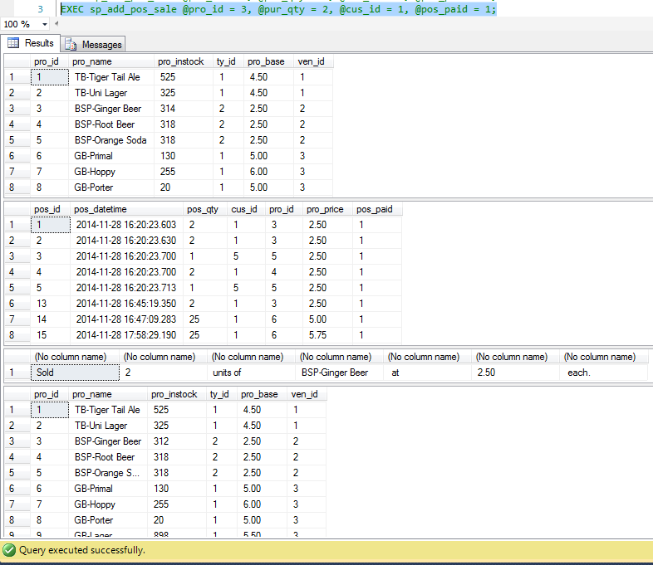

# 15 – The system must be able to display the unpaid items for a customer.

The following code creates a stored procedure to query the system for unpaid items for a customer.

/* CHECK IF PROCEDURE EXISTS, DROP AND RECREATE IT */

IF OBJECTPROPERTY(object_id('sp_customer_tab'), N'IsProcedure') = 1

DROP PROCEDURE [dbo].[sp_customer_tab]

GO

CREATE PROCEDURE dbo.sp_customer_tab

@cus_id INT

AS

BEGIN

/* ROLLBACK IF AN ERROR HAS OCCURRED */

IF NOT EXISTS (SELECT * FROM T_CUSTOMER WHERE cus_id = @cus_id)

BEGIN

SELECT 'Invalid Customer!'

RETURN

END

/* ITEMIZED LIST OF UNPAID ITEMS */

SELECT pro.pro_name, s.pro_price, s.pos_qty

FROM t_customer c

INNER JOIN t_pos_sales s ON c.cus_id=s.cus_id

INNER JOIN t_product pro ON pro.pro_id=s.pro_id

WHERE s.pos_paid=0

AND s.cus_id = @cus_id

/* CUSTOMER NAME AND SUBTOTAL */

SELECT c.cus_fname, c.cus_lname,sum(s.pro_price) AS SubTotal

FROM t_customer c

INNER JOIN t_pos_sales s ON c.cus_id=s.cus_id

INNER JOIN t_product pro ON pro.pro_id=s.pro_id

WHERE s.pos_paid=0

AND s.cus_id = @cus_id

GROUP BY c.cus_id,c.cus_fname, c.cus_lname

END

Select c.cus_fname, c.cus_lname,sum(s.pro_price) As SubTotal

from t_customer c

inner join t_pos_sales s on c.cus_id=s.cus_id

inner join t_product pro on pro.pro_id=s.pro_id

where s.pos_paid=0

and s.cus_id = @cus_id

group by c.cus_id,c.cus_fname, c.cus_lname

End

This screen capture demonstrates an execution of stored procedure for an existing customer.



This screen capture demonstrates the validation for an existing customer.



# 16 - The system must be able to predict when to order inventory based on sales and current inventory levels.

This procedure uses 30 days of average sales to determine how many days of a product remain, given the current level of inventory. It creates temporary tables and then custom messages.

use gibino

if objectproperty(object_id('dbo.sp_rem_inv'), N'IsProcedure') = 1

drop procedure dbo.sp_rem_inv

go

IF OBJECT_ID('dbo.t_tmp_sales_30', 'U') IS NOT NULL

drop table dbo.t_tmp_sales_30

go

IF OBJECT_ID('dbo.t_tmp_inv_remain', 'U') IS NOT NULL

drop table dbo.t_tmp_inv_remain

go

create proc sp_rem_inv

as begin

begin transaction

--Creates temporary table showing average sales for past thirty days

select a.pro_id, sum(a.acct_qty)/30 as dailysold into t_tmp_sales_30

from t_acct_sales a

where a.acct_datetime >= dateadd (day,-10000, getdate() )

group by a.pro_id;

--Creates temporary table showing amount on hand, given current inventory

select p.pro_id, p.pro_name, p.pro_instock/nullif(s.dailysold,0) as invdays, s.dailysold, p.pro_instock into t_tmp_inv_remain

from t_product p left join t_tmp_sales_30 s

on p.pro_id=s.pro_id;

--Creates messages for when:

-- There is no product in stock but there have been sales.

-- There is product in stock and there have not been sales.

-- There is product in stock and there have been sales.

select inv_message =

case

when inv.pro_instock = 0 then inv.pro_name+ ' - No' +inv.pro_name+ ' in stock. The average daily sales are '+cast(dailysold as varchar)+' units.'

when inv.invdays is NULL then inv.pro_name+ ' - There is not enough sales information to determine amount of ' + cast(inv.pro_name as varchar) + ' in stock. There are currently ' + cast(inv.pro_instock as varchar) + ' in stock.'

else inv.pro_name+ '- There are '+cast(inv.invdays as varchar)+' days (estimated) of'+inv.pro_name+ ' product remaining.'

end

from

t_tmp_inv_remain inv

order by inv_message

--Message for rollback

if @@error<>0

begin

rollback transaction

select 'Unable to process inventory levels.'

return

end

--Message for success

commit transaction

select 'Inventory levels processed. Please refer to output.'

end

The following output shows the inventory messages which appear when the query is run.

* When a beverage has a 30-day sales history and product in-stock, a message with the number of remaining days of inventory appears.
* When a beverage does not have 30-day sales history but does have product in-stock, a message indicates that there is not enough sales history to predict days-on-hand. The message also displays the number of units in stock.
* When a beverage is not in stock, the messages indicates that the beverage is not in stock, and the message also includes the average daily sales for that beverage.



# 17 - The system must be able to generate profit report.

--Profit Report

IF OBJECT_ID ('Profit_Report', 'P') IS NOT NULL

DROP PROCEDURE Profit_Report;

GO

CREATE PROCEDURE Profit_Report

@Start_Date datetime,

@End_Date datetime

AS

Begin

Begin transaction

--To check if any transaction occured on given date parameter

if not exists (select * from t_POS_Sales where pos_datetime between @Start_Date and @End_Date)

Begin

Select 'Error! No Report Found'

end

--If transaction exists select--

If exists (select pro_id from t_POS_Sales where pos_datetime between @Start_Date and @End_Date)

Begin Try

Select tpr.pro_id,tpr.pro_name, (Sum(ts.pro_price*ts.pos_qty)-sum(tpu.pur_unt_price*ts.pos_qty)) As Net_Profit

from t_purchase tpu join t_product tpr on tpr.pro_id=tpu.pro_id join t_pos_sales ts on tpr.pro_id=ts.pro_id

where ts.pos_datetime between @Start_Date and @End_Date

Group by tpr.pro_id,tpr.pro_name

Order by tpr.pro_id;

END TRY

--Error Check

BEGIN CATCH

SELECT

ERROR_NUMBER() AS ErrorNumber,

ERROR_SEVERITY() AS ErrorSeverity,

ERROR_STATE() as ErrorState,

ERROR_PROCEDURE() as ErrorProcedure,

ERROR_LINE() as ErrorLine,

ERROR_MESSAGE() as ErrorMessage;

IF @@TRANCOUNT > 0

ROLLBACK TRANSACTION;

End Catch;

IF @@TRANCOUNT > 0

COMMIT TRANSACTION

End;

--Exec Profit_Report @Start_Date='10/10/14',@End_Date='10/21/14'

This screenshot demonstrates the successful generation of Profit report

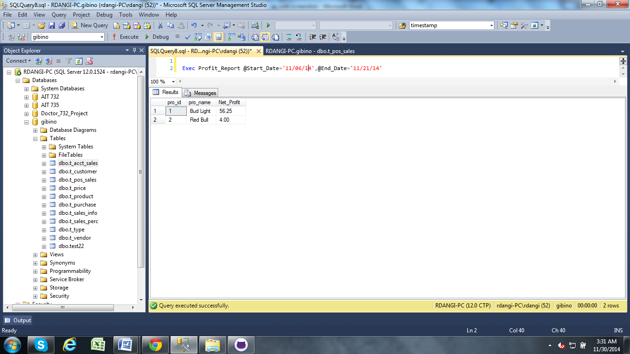

This screenshot demonstrates a failed attempt of generation of Profit report- NO REPORT FOUND



# 18- The system must be able to display total number of inventory sold by type per day

**18A. Generation of Alcoholic Product Sales report:**

--Alcoholic drinks Sales Report:

IF OBJECT_ID ('ALCOHOL_SALES_REPORT', 'P') IS NOT NULL

DROP PROCEDURE ALCOHOL_SALES_REPORT;

GO

CREATE PROCEDURE ALCOHOL_SALES_REPORT

@Start_Date datetime,

@End_Date datetime

AS

Begin

Begin transaction

--To check if any transaction occured on given date parameter

if not exists (select * from t_POS_Sales where pos_datetime between @Start_Date and @End_Date)

Begin

Select 'Error! No Report Found'

end

--If transaction exists select--

If exists (select * from t_POS_Sales where pos_datetime between @Start_Date and @End_Date)

Begin Try

SELECT tp.pro_id,tp.pos_qty,SUM(tp.pos_paid)as Total_Sales, p.pro_name

FROM T_POS_SALES tp

join t_product p

on tp.pro_id=p.pro_id join t_type tt

on p.ty_id=tt.ty_id

where tp.pos_datetime between @Start_Date and @End_Date AND tt.TY_RESTRICTED=1

Group by tp.pro_id,pos_qty,p.pro_name

Order by tp.pro_id;

END TRY

--Error Check

BEGIN CATCH

SELECT

ERROR_NUMBER() AS ErrorNumber,

ERROR_SEVERITY() AS ErrorSeverity,

ERROR_STATE() as ErrorState,

ERROR_PROCEDURE() as ErrorProcedure,

ERROR_LINE() as ErrorLine,

ERROR_MESSAGE() as ErrorMessage;

IF @@TRANCOUNT > 0

ROLLBACK TRANSACTION;

End Catch;

IF @@TRANCOUNT > 0

COMMIT TRANSACTION

END;

--Exec ALCOHOL_SALES_REPORT @Start_Date='09/10/14',@End_Date='09/21/14'

This screenshot demonstrates the successful generation of Sales report for Alcohol product.

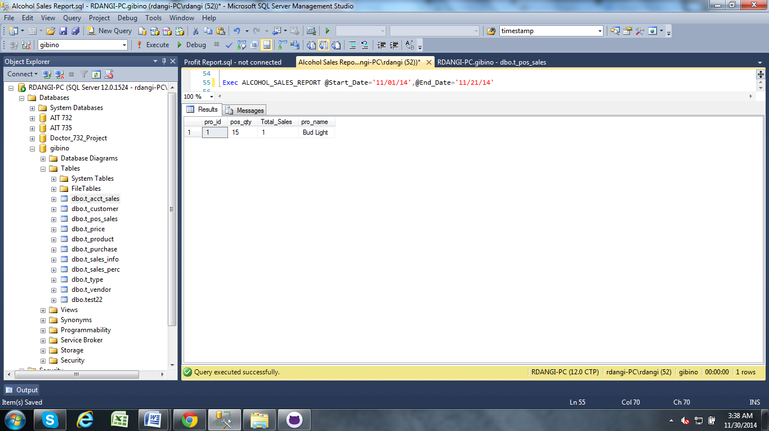

This screenshot demonstrates the failed attempt of generation of Sales report for Alcohol product.



**18B. Generation of Non- Alcohol Product Sales report:**

--NON_ Alcohol drinks Sales Report:

IF OBJECT_ID ('NON_ALCOHOL_SALES_REPORT', 'P') IS NOT NULL

DROP PROCEDURE NON_ALCOHOL_SALES_REPORT;

GO

CREATE PROCEDURE NON_ALCOHOL_SALES_REPORT

@Start_Date datetime,

@End_Date datetime

AS

Begin

Begin transaction

--To check if any transaction occured on given date parameter

if not exists (select * from t_POS_Sales where pos_datetime between @Start_Date and @End_Date)

Begin

Select 'Error! No Report Found'

end

--If transaction exists select--

If exists (select * from t_POS_Sales where pos_datetime between @Start_Date and @End_Date)

Begin Try

SELECT tp.pro_id,tp.pos_qty,SUM(tp.pos_paid)as Total_Sales,p.pro_name

FROM T_POS_SALES tp

join t_product p

on tp.pro_id=p.pro_id join t_type tt

on p.ty_id=tt.ty_id

where tp.pos_datetime between @Start_Date and @End_Date AND tt.TY_RESTRICTED=2

Group by tp.pro_id,pos_qty,p.pro_name

Order by tp.pro_id;

END TRY

--Error Check

BEGIN CATCH

SELECT

ERROR_NUMBER() AS ErrorNumber,

ERROR_SEVERITY() AS ErrorSeverity,

ERROR_STATE() as ErrorState,

ERROR_PROCEDURE() as ErrorProcedure,

ERROR_LINE() as ErrorLine,

ERROR_MESSAGE() as ErrorMessage;

IF @@TRANCOUNT > 0

ROLLBACK TRANSACTION;

End Catch;

IF @@TRANCOUNT > 0

COMMIT TRANSACTION

End;

--Exec NON_ALCOHOL_SALES_REPORT @Start_Date='09/10/14',@End_Date='09/21/14'

This screenshot demonstrates the successful generation of Sales report for Non- Alcohol product.

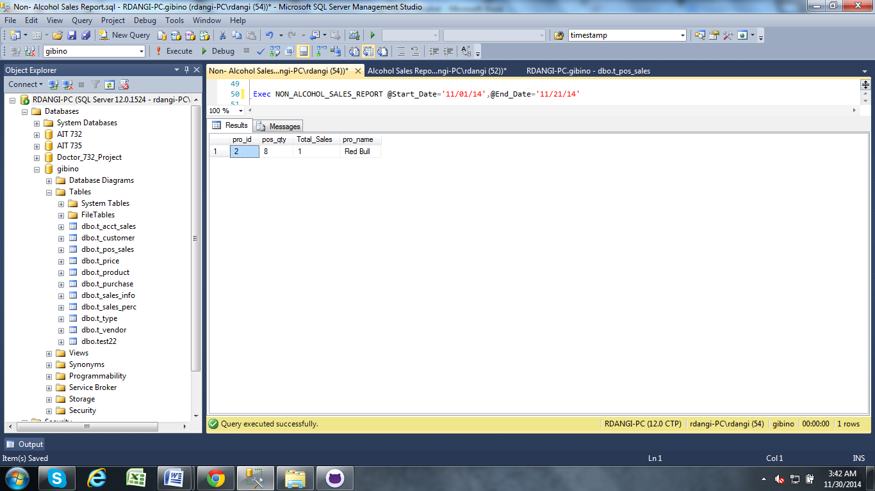

This screenshot demonstrates the failed attempt of generation of Sales report for Non-Alcohol product.



# 19 – The system must be able to display total revenue for a day

--Daily Revenue Report

IF OBJECT_ID ('Daily_Revenue_Report', 'P') IS NOT NULL

DROP PROCEDURE Daily_Revenue_Report;

GO

CREATE PROCEDURE Daily_Revenue_Report

@Sales_date datetime

As

Begin

Begin transaction

--To check if any transaction occured on given date parameter

if not exists (select * from t_Acct_Sales where @Sales_date=acct_datetime)

Begin

Select 'Error! No Transaction Found.'

end

--If transaction exists select--

If exists (select * from t_Acct_Sales where @Sales_date=acct_datetime)

BEGIN TRY

Select ta.pro_id,tp.pro_name, Sum(ta.acct_qty*ta.acct_qty) As Net_Sales

from t_product tp join t_acct_sales ta on ta.pro_id=tp.pro_id

where @Sales_date=ta.acct_datetime

group by ta.pro_id,tp.pro_name

Order by ta.pro_id

END TRY

--Error Check

BEGIN CATCH

SELECT

ERROR_NUMBER() AS ErrorNumber,

ERROR_SEVERITY() AS ErrorSeverity,

ERROR_STATE() as ErrorState,

ERROR_PROCEDURE() as ErrorProcedure,

ERROR_LINE() as ErrorLine,

ERROR_MESSAGE() as ErrorMessage;

IF @@TRANCOUNT > 0

ROLLBACK TRANSACTION;

End Catch;

IF @@TRANCOUNT > 0

COMMIT TRANSACTION

End;

--Exec Daily_Revenue_Report @Sales_date='2014-12-06'

This screenshot demonstrates the successful generation of Revenue report based on POS date.

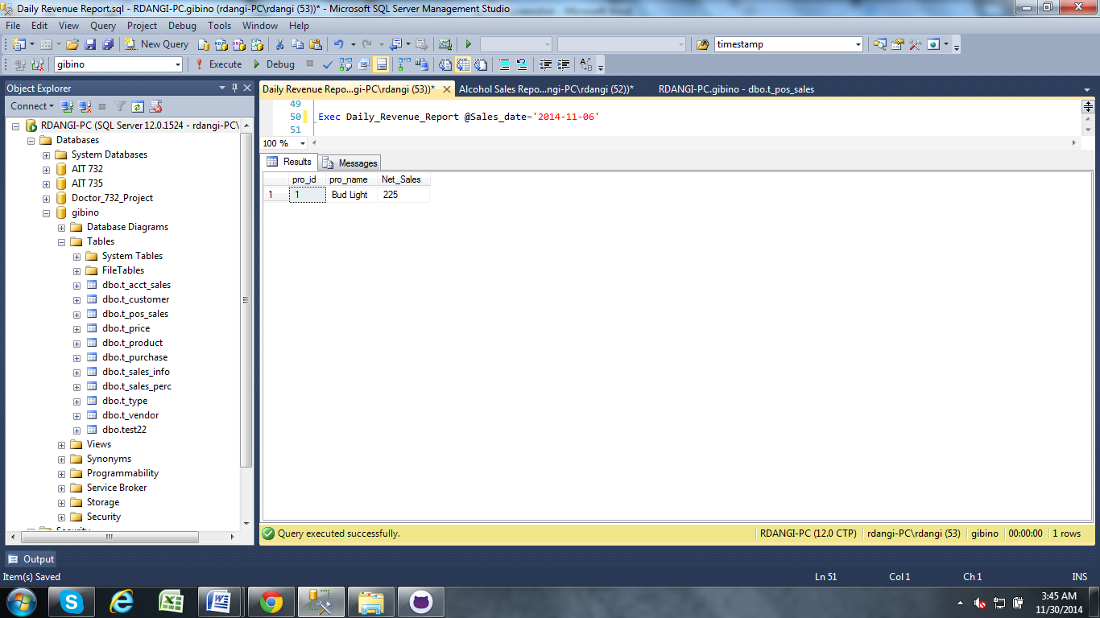

This screenshot demonstrates the s failed attempt of generation of Revenue report based on POS date.



# 20 - The system must display monthly sales reports.

--Sales_Report

IF OBJECT_ID ('Sales_REPORT', 'P') IS NOT NULL

DROP PROCEDURE Sales_REPORT;

GO

CREATE PROCEDURE Sales_REPORT

@Start_Date datetime,

@End_Date datetime

AS

Begin

Begin transaction

--To check if any transaction occured on given date parameter

If not exists (select * from t_POS_Sales where pos_datetime between @Start_Date and @End_Date)

Begin

Select 'Error! No Report Found'

end

--If transaction exists select--

If exists (select * from t_POS_Sales where pos_datetime between @Start_Date and @End_Date)

Begin Try

SELECT tp.pro_id,tp.pos_qty,SUM(tp.pro_price * tp.pos_qty)as Total_Sales,p.pro_name

FROM T_POS_SALES tp

join t_product p

on tp.pro_id=p.pro_id join t_type tt

on p.ty_id=tt.ty_id

where tp.pos_datetime between @Start_Date and @End_Date

Group by tp.pro_id,pos_qty,p.pro_name

Order by tp.pro_id;

END TRY

--Error Check

BEGIN CATCH

SELECT

ERROR_NUMBER() AS ErrorNumber,

ERROR_SEVERITY() AS ErrorSeverity,

ERROR_STATE() as ErrorState,

ERROR_PROCEDURE() as ErrorProcedure,

ERROR_LINE() as ErrorLine,

ERROR_MESSAGE() as ErrorMessage;

IF @@TRANCOUNT > 0

ROLLBACK TRANSACTION;

End Catch;

IF @@TRANCOUNT > 0

COMMIT TRANSACTION

END;

--Exec Sales_REPORT @Start_Date='09/11/14',@End_Date='10/10/14'

This screenshot demonstrates the successful generation of Sales report based on POS date.

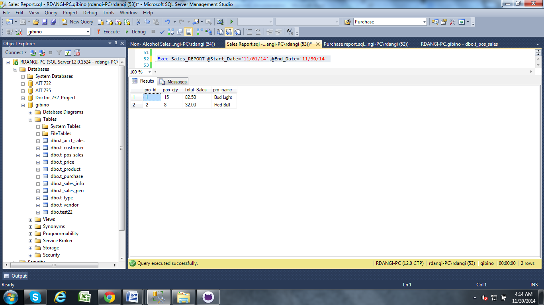

This screenshot demonstrates the failed attempt of generation of Sales report based on POS date.



# 21- The system must display monthly purchase reports.

--Purchase_Report

IF OBJECT_ID ('Purchase_REPORT', 'P') IS NOT NULL

DROP PROCEDURE PURCHASE_REPORT;

GO

CREATE PROCEDURE PURCHASE_REPORT

@Start_Date datetime,

@End_Date datetime

AS

Begin

Begin transaction

--To check if any transaction occurred on given date parameter

if not exists (select * from t_purchase where pur_date between @Start_Date and @End_Date)

Begin

Select 'Error! No Report Found'

end

--If transaction exists select--

If exists (select * from t_purchase where pur_date between @Start_Date and @End_Date)

Begin Try

SELECT tv.ven_id,tv.ven_name,tp.pur_id,tp.pro_id, sum(tp.pur_qty * tp.pur_unt_price) as Total_Paid,

p.pro_name, p.pro_id

from t_vendor tv join t_purchase tp on tv.ven_id=tp.ven_id

join t_product p on p.pro_id=tp.pro_id

where tp.pur_date between @Start_Date and @End_Date

group by tv.ven_id,tv.ven_name,tp.pur_id,tp.pro_id, p.pro_name, p.pro_id

order by tv.ven_id;

END TRY

--Error Check

BEGIN CATCH

SELECT

ERROR_NUMBER() AS ErrorNumber,

ERROR_SEVERITY() AS ErrorSeverity,

ERROR_STATE() as ErrorState,

ERROR_PROCEDURE() as ErrorProcedure,

ERROR_LINE() as ErrorLine,

ERROR_MESSAGE() as ErrorMessage;

IF @@TRANCOUNT > 0

ROLLBACK TRANSACTION;

End Catch;

IF @@TRANCOUNT > 0

COMMIT TRANSACTION

END;

--Exec Purchase_REPORT @Start_Date='09/10/14',@End_Date='11/21/14'

This screenshot demonstrates the successful generation of Purchase report based on purchase date.

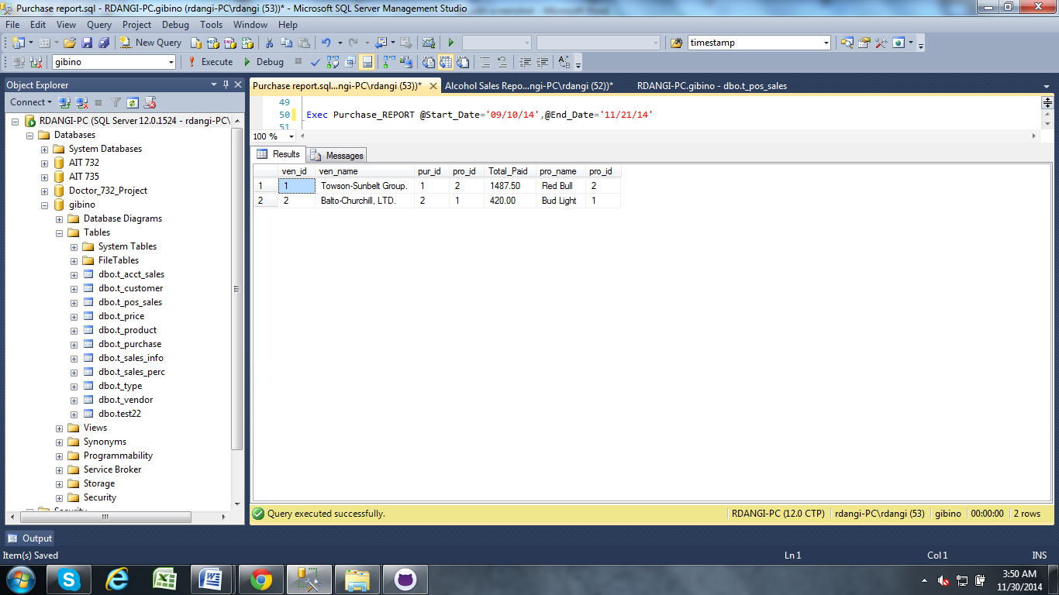

This screenshot demonstrates the failed attempt of generation of Purchase report based on purchase date.



# 22 – The system shall keep historical data.

The following code will create a stored procedure that will be run prior to purging the pos table to populate a permanent table which will keep historical information.

/* CHECK IF PROCEDURE EXISTS, DROP AND RECREATE IT */

IF OBJECTPROPERTY(object_id('dbo.sp_update_acct_sales'), N'IsProcedure') = 1

DROP PROCEDURE [dbo].[sp_update_acct_sales]

GO

CREATE PROCEDURE dbo.sp_update_acct_sales

AS

BEGIN

BEGIN TRANSACTION

/* INSERT DATA FROM THE POS TERMINAL INTO THE PERMANENT ACCOUNTING TABLE */

INSERT INTO T_ACCT_SALES (ACCT_DATETIME, ACCT_QTY, CUS_ID, PRO_ID, ACCT_PRICE)

SELECT pos_datetime, pos_qty, cus_id, pro_id, pro_price

FROM T_POS_SALES

WHERE POS_PAID = 1;

/* ROLLBACK ON ERROR */

IF @@error <> 0

BEGIN

ROLLBACK TRANSACTION

SELECT ' There was a problem migrating the sales information'

RETURN

END

COMMIT TRANSACTION;

SELECT * FROM T_ACCT_SALES;

END

This screen capture demonstrates the successful insert of data from the pos table.

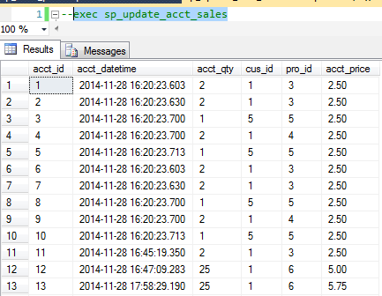

# 23 - The system must insert new purchases and update the inventory levels in the product table.

This stored procedure is used to purchase inventory. It validates that the vendor and product exists. It also validates that the purchase quantity is greater than zero. It writes to the purchase table and updates the inventory level in the products table.

use gibino

if objectproperty(object_id('dbo.sp_purchase_inventory'), N'IsProcedure') = 1

drop procedure dbo.sp_purchase_inventory

go

create procedure sp_purchase_inventory

(@pro_id int, @ven_id int, @pur_qty int, @pur_unt_price numeric(5,2), @pur_date datetime)

as

begin

--Checks that vendor and product exist in t_product

if not exists (select * from t_product where ven_id=@ven_id and pro_id=@pro_id)

begin

select 'Vendor and product do not exist in the product table'

return

end

else

--Checks that quantity purchase is >0

if @pur_qty <=0

begin

select 'A quantity greater than 0 must be purchased.'

return

end

--Inserts values into t_purchase table

begin transaction

insert into t_purchase

(pro_id, ven_id, pur_qty, pur_unt_price, pur_date)

values

(@pro_id, @ven_id, @pur_qty, @pur_unt_price, @pur_date);

--Updates inventory amount in t_product

update t_product

set pro_instock=pro_instock+@pur_qty

where pro_id=@pro_id

--Message for rollback

if @@error<>0

begin

rollback transaction

select 'Purchase was not completed.'

return

end

--Message for success

commit transaction

select 'Purchase successfully added for ', @pur_qty, 'units of ', (select pro_name from t_product where pro_id=@pro_id), ' at ', @pur_unt_price, ' each.'

end

This screenshot shows a successful purchase of a valid product.



This screenshot shows a failed attempt to purchase an invalid product.



This screenshot shows a failed attempt to purchase an invalid amount (<=0) of a product.



# 24 – The system must reset prices to their base levels.

The following code will create a stored procedure to reset product prices.

/* CHECK IF PROCEDURE EXISTS, DROP AND RECREATE IT */

IF OBJECTPROPERTY(object_id('dbo.sp_reset_price'), N'IsProcedure') = 1

DROP PROCEDURE [dbo].[sp_reset_price]

GO

CREATE PROCEDURE dbo.sp_reset_price

AS

BEGIN

BEGIN TRANSACTION

/* RESET PRICES BACK TO THEIR ORIGINAL PRICES */

UPDATE pri

SET pri.pro_price = pro.pro_base

FROM t_price pri INNER JOIN t_product pro

ON pri.pro_id = pro.pro_id;

IF @@error <> 0

BEGIN

ROLLBACK TRANSACTION

SELECT ' Sale was NOT completed'

RETURN

END

COMMIT TRANSACTION

SELECT * FROM T_PRICE;

END

This screen capture demonstrates the successful reset of product prices. Product 6 was at $5.75 after a price update, now all prices are reflective of their base price in T_PRODUCT.



# 25 - The system must be able to add new product types without duplicates.

This stored procedure inserts a new type (i.e., a volume and category of beverage). It validates that the type does not already exist in the system.

use gibino

if objectproperty(object_id('dbo.sp_add_pro_type'), N'IsProcedure') = 1

drop procedure dbo.sp_add_pro_type

go

create procedure sp_add_pro_type

(@ty_description varchar(50), @ty_restricted int)

as

begin

--Checks for duplicate product type

if exists (select * from t_type where upper(replace(ty_description, ' ', ''))=upper(replace(@ty_description, ' ', '')))

begin

select UPPER(@ty_description), 'already exsists as a product type in the system.'

return

end

--Inserts vendor information into t_vendor table

begin transaction

insert into t_type

(ty_description, ty_restricted)

values

(@ty_description, @ty_restricted)

--Message for rollback

if @@error<>0

begin

rollback transaction

select @ty_description, ' not added to the system.'

return

end

--Message for success

commit transaction

select @ty_description, ' was successfully added to the system.'

end

This screenshot shows a successful insertion of a new type of product.

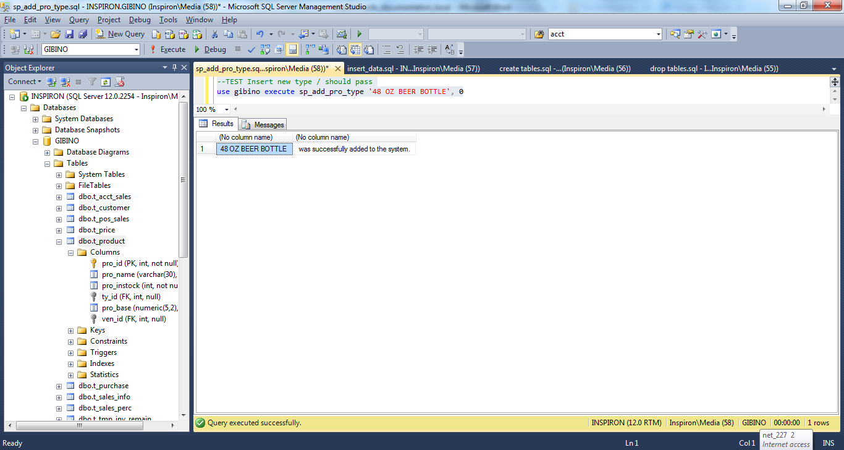

This screenshots shows a failed attempt to insert a type of product which already exists in the system.



# 26 - The system must be able to insert new customers without duplicates.

This stored procedure is used to insert new customers. It validates that the system does not already contain a customer with the same first name, last name, and date of birth.

use gibino

if objectproperty(object_id('dbo.sp_add_customer'), N'IsProcedure') = 1

drop procedure dbo.sp_add_customer

go

create procedure sp_add_customer

(@cus_dob datetime, @cus_street1 varchar(30), @cus_street2 varchar(30), @cus_city varchar(30), @cus_state char(2), @cus_zip numeric(5,0),

@cus_email varchar(50), @cus_fname varchar(25), @cus_lname varchar(30), @cus_mi varchar(1), @cus_suffix varchar(5))

as

begin

--Checks for duplicate customer names with the same date of birth.

if exists (

select * from t_customer where upper(replace(cus_fname, ' ', '' ))=upper(replace(@cus_fname, ' ', '' ))

and upper(replace(cus_lname, ' ', '' ))=upper(replace(@cus_lname, ' ', '' ))

and cast(cus_dob as date)=cast(@cus_dob as date)

)

begin

select @cus_fname, @cus_lname, 'already exsists in this system as a customer.'

return

end

--Inserts vendor information into t_customer table

begin transaction

insert into t_customer

(cus_dob, cus_street1, cus_street2, cus_city, cus_state, cus_zip,

cus_email, cus_fname, cus_lname, cus_mi, cus_suffix)

values

(@cus_dob, @cus_street1, @cus_street2, @cus_city, @cus_state, @cus_zip,

@cus_email, @cus_fname, @cus_lname, @cus_mi, @cus_suffix)

--Message for rollback

if @@error<>0

begin

rollback transaction

select 'Customer, ', @cus_fname, @cus_lname, ' not added.'

return

end

--Message for success

commit transaction

select 'Customer, ', @cus_fname, @cus_lname, ' was added.'

end

This screenshot shows the successful insertion of a new customer.

